MAC address are always listed using the 0-9 and A-E as:
00:00:00:00:00:00
OR
00-00-00-00-00-00

Streaming Media Devices
Google Chromecast
Open the Chromecast app on your computer or mobile device and click Settings. The MAC address is located in the bottom-left corner of the menu.
AppleTV
Settings -> About. The MAC address will be listed as Wireless ID.
Roku
Settings -> About
Amazon Fire TV Stick
Settings -> System -> About
Amazon Fire TV
Settings -> Device Info
Smart TV/Bluray Player
The MAC address is usually found under Settings -> Network -> About, but you may need to Google your model of device to see exactly how to find the MAC address.

Nintendo Game Consoles
Nintendo 3DS
Home menu -> System Settings -> Internet Settings -> Other Information -> Confirm MAC Address
Nintendo DS
Insert a WiFi compatible game and access the WFC Setup Utility in the game's menu. Select Options->System Information
Nintendo Wii U
Wii U Menu -> System Settings -> System Information
Nintendo Wii
Settings -> Internet -> Console Settings

Microsoft Game Consoles
XBox One
My Games & Apps -> Settings -> Network -> Advanced Settings
XBox 360
My XBox -> System Settings -> Network Settings -> Select the MU-BYOD network -> Configure Network -> Additional Settings tab -> Advanced Settings

Sony Game Consoles
Playstation 4
Settings -> Network -> View Connection Status
Playstation 3
Settings -> System Settings -> System Information
Sony PSP
System Settings -> System Information

Wireless Printers
At this time wireless printers are not officially supported on the UVic-BYOD network.
We recommend purchasing a printer which supports Cloud, Bluetooth or USB connectivity.
Cloud printing
If you have a printer which supports Cloud Printing, this may be feasible on the UVic-BYOD network, but you must investigate your printer to see whether it supports this function.
You register your printer via web portal – Google your model of printer, and “how to find MAC address of”. You connect your printer to the wireless network as a client, and disable wifi broadcasting or wifi direct on the printer. You would then use a cloud printing service (Google Cloud Print, for example) to send print jobs to the printer.

Google Home and Chromecast
These devices require a very low level of security. They must have uPnP enabled on the network, and allow all other devices on the same network to talk to them.
This means we must allow all other devices on the network to be able to cast to them, there is no option to secure them, which means anyone can cast to your device from UVic.
We are working to improve security on this, but access to Google Homes from the Google Home app may be restricted in the meantime.
This is a limited workaround:
  - Open the mobile app
  - In the top right corner of the Home screen, tap Devices
  - Now, scroll to find the device card for the Google Home you'd like prevent from sending cast notifications
  - Next, in the top right corner of the device card, tap the device card menu. That's the three-dot menu.
  - Under "Device info," turn OFF "Let others control your casted media"
This will limit users from knowing when you are casting.

Amazon Alexa and Echo Dot, FireTV
The Amazon devices use the Alexa app and talk directly to Amazon. You can connect over different wireless networks and control Amazon devices without being directly on the same network.
This also works with the FireTV app and FireStick or FireTV. Because of this, these devices are more easily adapted to the campus infrastructure.

Smart Automation devices – Plugs, Lights, etc
These devices are not supported on the UVic wireless network.

Where do I find the MAC address?
Apple TV
- Go to the main menu and select "Settings"
- Select "General" then select "About"
- Look for "Wi-Fi Address"

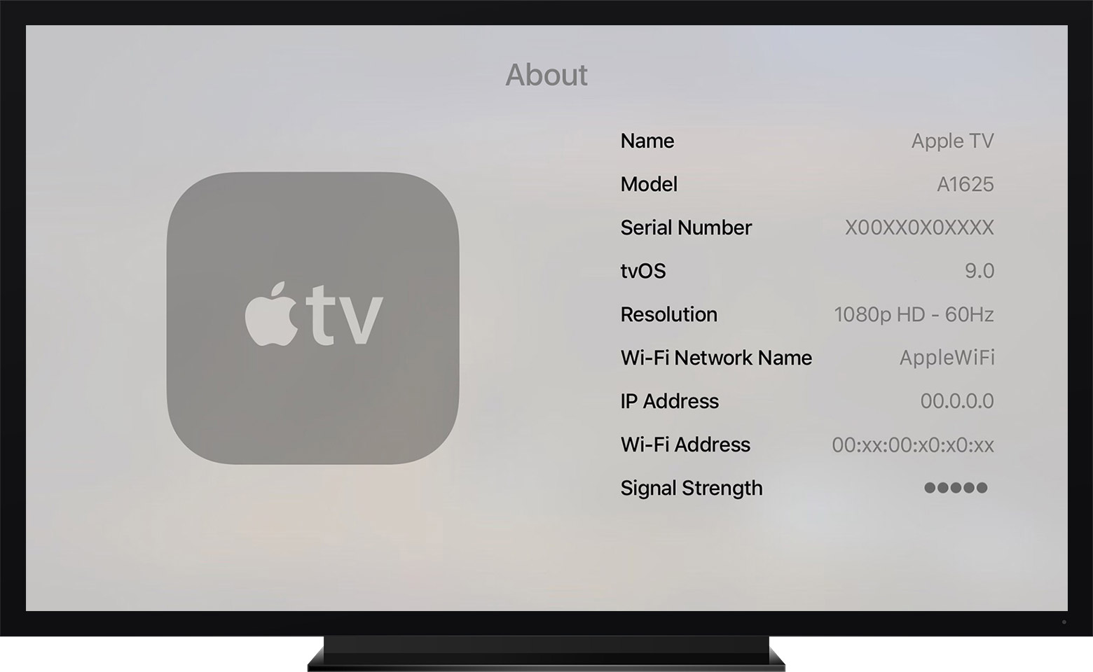

Nintendo Wii
- Press the A button on your remote to reach the Wii Menu
- Use the Wii Remote to select the "Wii" button
- Select "Wii Settings"
- Use the Arrow on the right side of the screen, scroll to page two and select "Internet"
- Select "Console Information"
- The MAC address will show at the top of the screen

Nintendo Wii U
- From the Wii U Menu, select "System Settings"
- Using the left stick select the "Internet" icon and press the A button

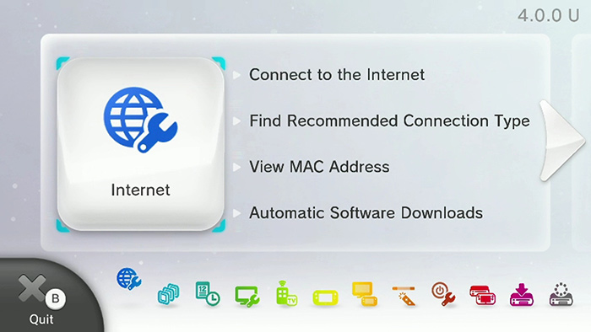

- Select "View MAC Address" and wait for moment for the MAC address to be displayed.
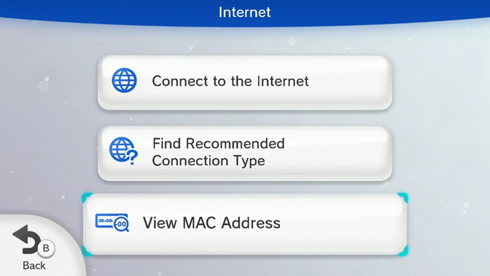

Playstation 3
- In the XMB home menu go to Settings > System Settings and press the [X] button
- Scroll down until you see "System Information" and press the [X] button
- You will then see your MAC address

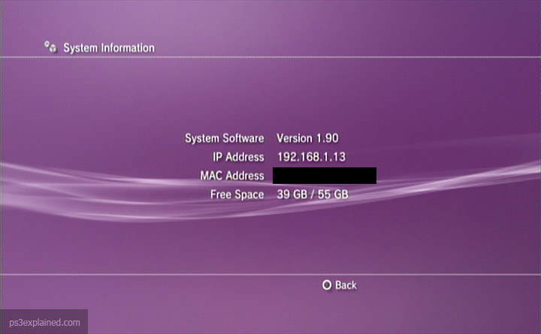

Playstation 4
- Navigate to the "Settings" icon
- Select "System"
- Select "System Information"
- You will then see both MAC addresses listed (one for Wi-Fi and one for LAN cable)

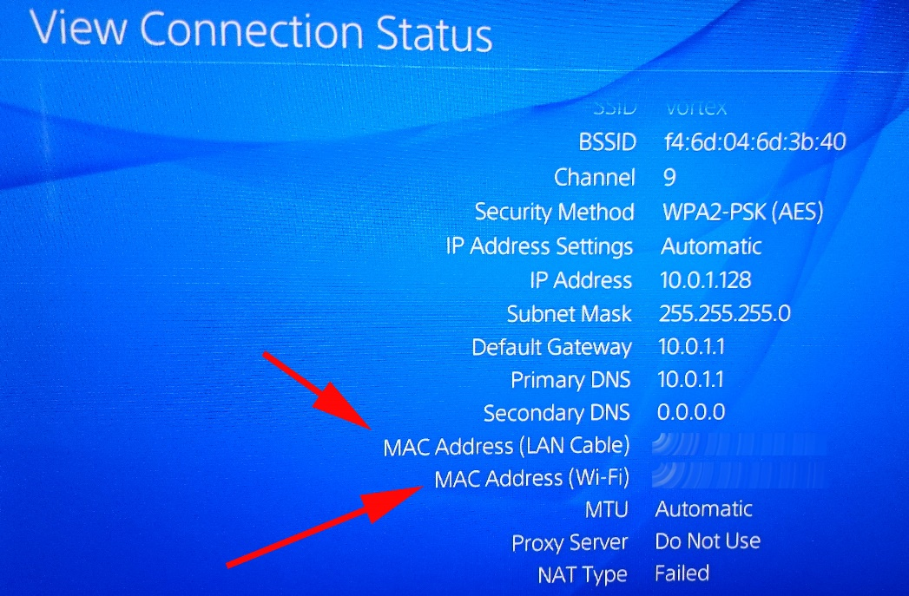

Xbox One
- Navigate to "My Games & Apps"
- Select "Settings" then "All Settings"
- In the settings pane, select "Network" then "Network Settings"
- Select "Advanced Settings"
- You will see both wired and wireless MAC addresses listed.
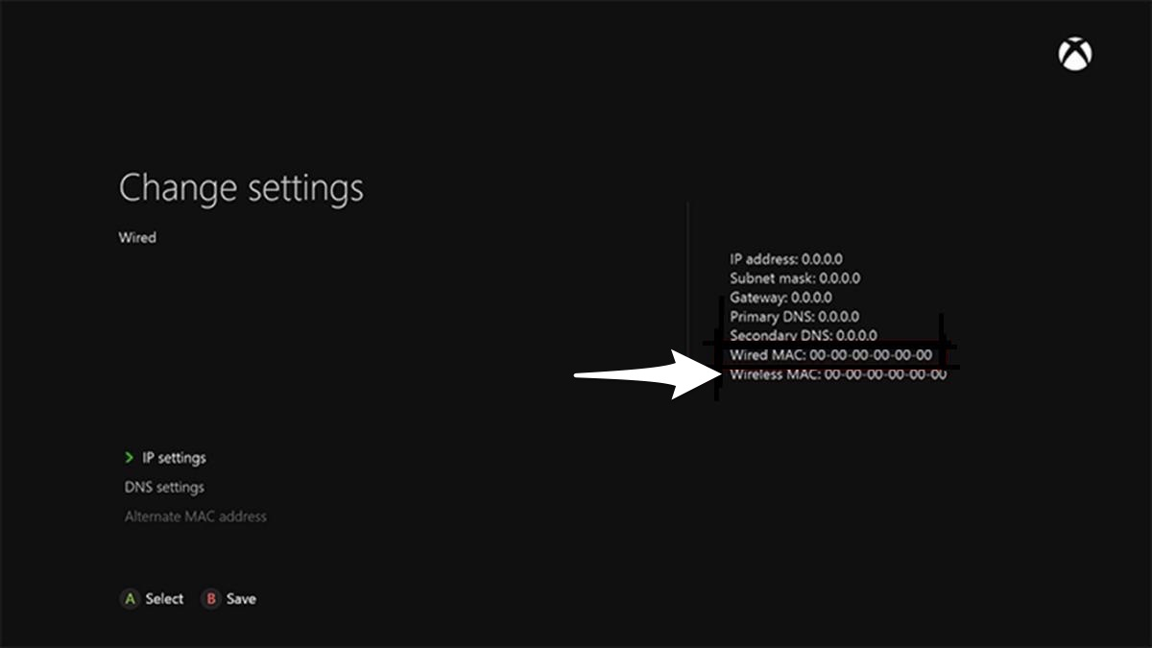

Xbox 360
- Navigate to My Xbox on the Xbox Dashboard
- Select System Settings
- Select Networking Settings
- Select Configure Network
- Go to Additional Settings
- Select Advanced Settings
- the MAC address for the wired and wireless adapters should then show.
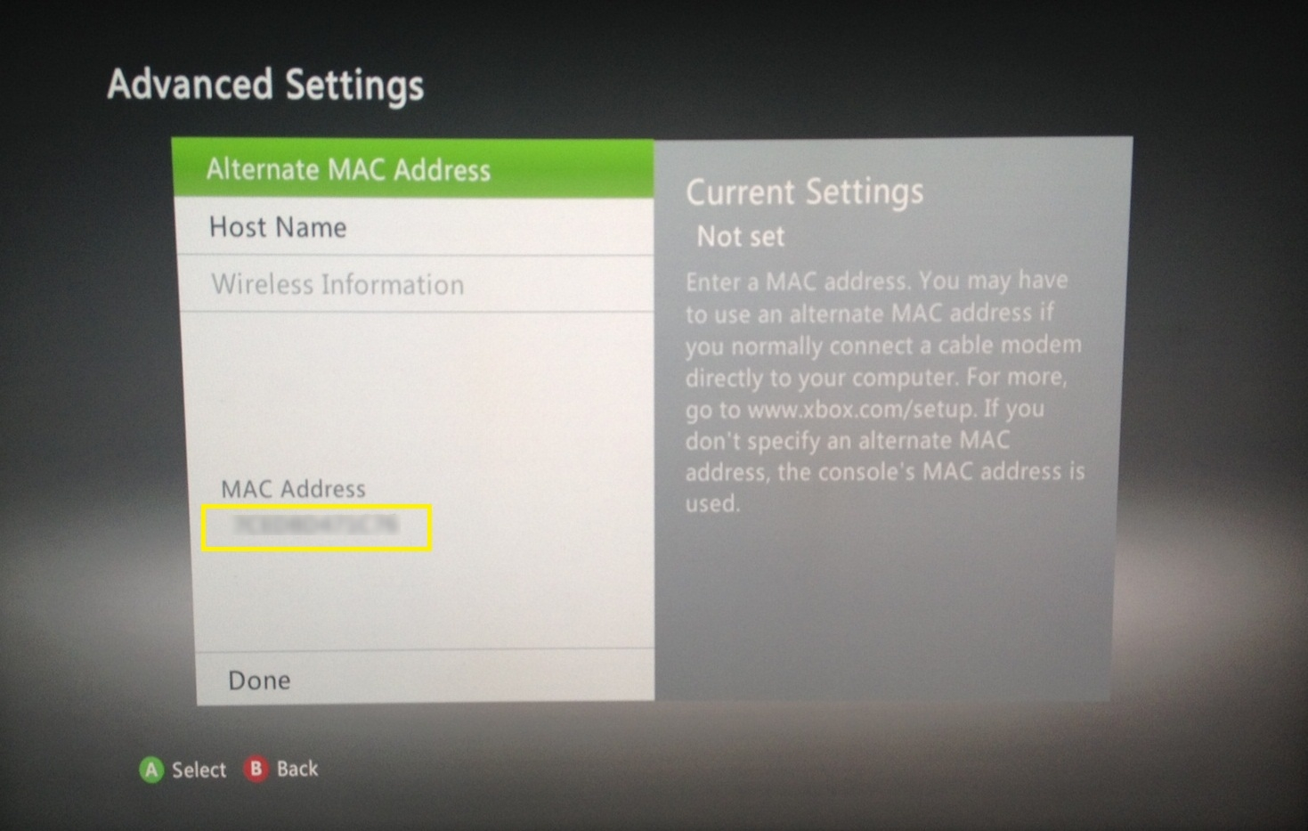

Roku
- Go to Settings and hit OK
- Select "System" and hit OK
- Then select "About" and hit OK
- You should then see the MAC address of both the wireless and wired connection depending on the device

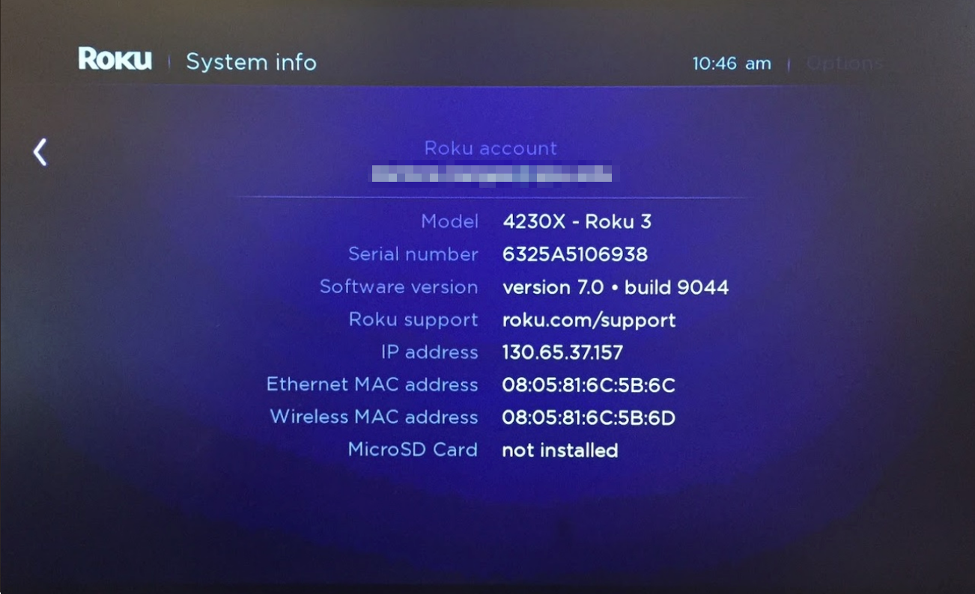

Amazon Fire TV / Stick
- From the Main Menu go to Settings
- Select "System"
- Then go to "About"
- Toggle down to Network
- Look for the MAC Address (Wi-Fi)
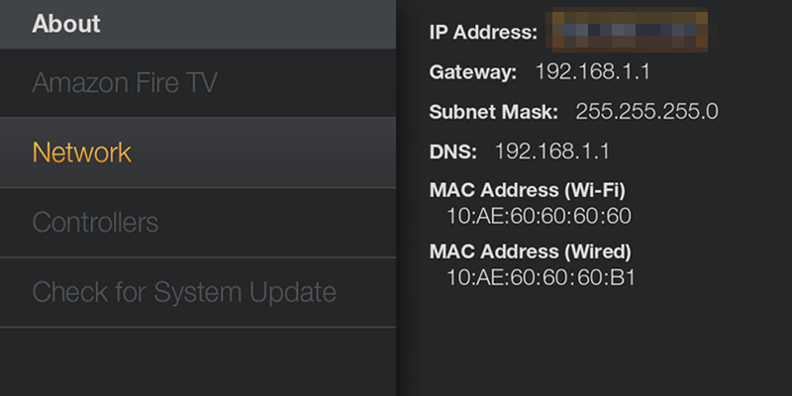

Smart TVs and other devices
Due to the large number of vendors for these devices we do not provide specific instructions. We do offer these suggestions:
- Look in the Settings menu on the device, either in the About or Networking portion if applicable.
- Look at the manufacture's website or documentation.
- Do a Google search, for example "how to find the mac address of vizio tv"

How to find my MAC Address
Nintendo Switch
Nintendo 3DS
Nintendo Wii
Nintendo Wii U
Xbox 360
Xbox One
Playstation Vita
Playstation 3
Playstation 4
Apple TV
Roku
Amazon FireStick/FireTV
Amazon Echo Dot
Google Chromecast
Google Home
Blu-Ray
Windows 7/8/10 PC
Apple MAC-OSX 1 2
Ubuntu

