Individualized Practicum Goal Setting

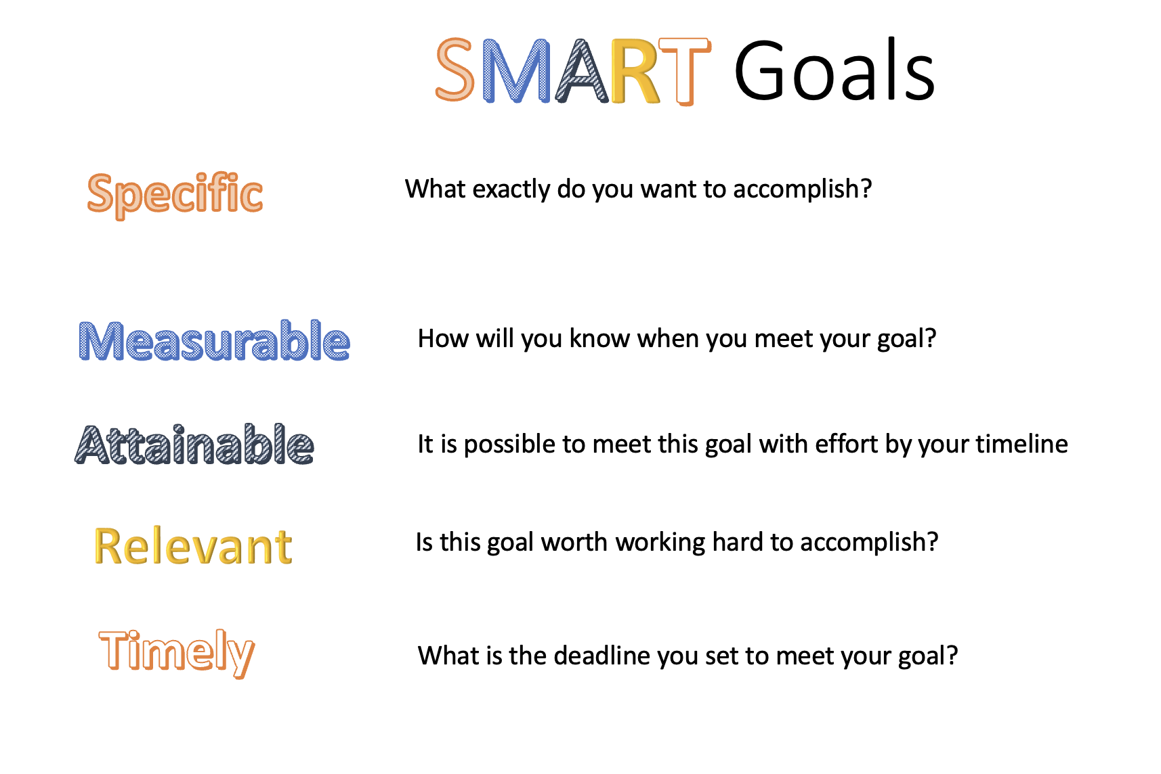

- These goals should be decided upon at the beginning of the practicum in a collaborative discussion between the student and the supervisor.
- These goals are not meant to be adhered to in a rigid manner but are to be used as guides for the student and supervisor to focus the student’s training experience.
- The number of goals will vary depending on student, supervisor, service, and setting.
- Significant concerns about a student’s rate of progress on a specific goal should be identified early enough in the practicum experience to allow for the student and supervisor to discuss ways to support the student in making the necessary improvements.

The following format may be copied as many times as needed to cover the goals developed at the beginning of the practicum.

Goal #__:

Ways to meet goal:

Way to assess if met:

Status at end of practicum:

Supervisor’s perspective:

Student’s perspective:

EXAMPLE

Goal: Further reduction in STUDENT’s anxiety related to conducting therapy.

Ways to meet goal: (a) Having greater experience, (b) work together on STUDENT being more comfortable with therapy not going exactly as planned and (c) working together to help STUDENT better balance the amount of time spent preparing with his ability to tolerate uncertainty.

Way to assess if met: (a) Decrease in STUDENT’s subjective experience of anxiety at the end of his practicum and (b) decrease (slowly across the practicum) in STUDENT’s reliance on extra supervision.

Status at end of practicum:
Supervisor’s perspective: I look forward to hearing STUDENT’s thoughts regarding this goal. I noticed a significant increase in their comfort in therapy as demonstrated by their decreased use of extra supervision, their decreased need for detailed session plans, and increased willingness to trust their own instincts.

STUDENT’s perspective:
(the student provides comments at time of evaluation)

To promote consistency with the newest (2023) CPA Accreditation standards, please include at least one goal related to awareness and sensitivity to individual, social and cultural diversity.

EXAMPLE

Goal: Better understand how to ask about a client’s culture during therapy.

Ways to meet goal: (a) review culturally responsive assessment questions (b) use supervision to discuss how asking about culture has played an important role in SUPERVISOR’s experience, and (c) practice asking about culture with each client (with the understanding that every client has a culture).

Way to assess if met: (a) STUDENT engages in thoughtful discussion during clinical supervision and (b) STUDENT practices asking clients about culture in sensitive and informed ways during therapy.

Status at end of practicum:
Supervisor’s perspective: STUDENT and I had an ongoing set of thoughtful discussions about culture and aspects of diversity during supervision. STUDENT was able to develop skills in asking clients about culture and actively applied these in therapy.

STUDENT’s perspective:
(the student provides comments at time of evaluation)

