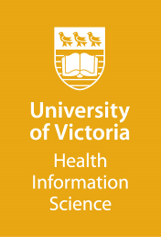
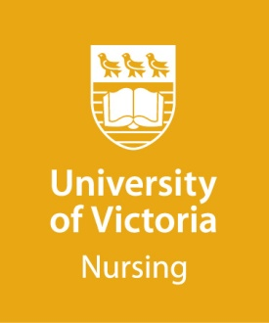
MASTER OF NURSING and MASTER OF SCIENCE IN HEALTH
INFORMATICS
Double Degree Program
guidelines for personal statement
(Maximum 500 words)

The personal statement is an important part of the application process and provides a formal sample of the applicant’s writing. The development of the personal statement provides an opportunity for the candidate to reflect upon their preparation and goals in pursuing their Master of Nursing and Master of Science in Health Informatics Double Degree program.

The personal statement provides the selections committee with the evidence of the applicant’s knowledge, commitment and experience towards the pursuit of the Master of Nursing and Master of Science in Health Informatics Double Degree program.

Your personal statement should clearly address the following questions in detail (point form is not acceptable):

- Reflecting on your practice experiences and the goals of the Master of Nursing and Master of Science in Health Informatics Double Degree program option, describe your interest in pursuing nursing informatics at the graduate level.

- In particular, why have you applied to the double degree program rather than just the MN or MSc in Health Informatics?

- What issues, problems or research questions are of most interest to you as you consider pursuing graduate studies in this program?

- Do you have any training or educational background regarding information technology (e.g. are there any courses you have taken about computers, programming, information technology, or any training you have received about health information technology). If so, please describe.

- In what capacities have you used, designed, deployed, or implemented health information technologies (including providing training to others about systems such as electronic health records)? Please describe in detail.

- Please indicate what course(s) you have taken in statistics and provide the dates of enrolment and course completion.

(Optional: Attach a SHORT sample of your professional or academic writing to your personal statement if you wish, i.e. excerpt from journal article, formal report, etc.).

Please submit your personal statement with your online application.

If you have any questions, please contact the Double Degree Program Coordinator via gradnurs@uvic.ca , prior to submitting your application.
Personal Statement

