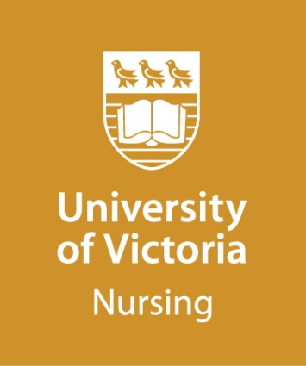
MASTER OF NURSING (MN)

Indigenous Wellness (INDW)
Guidelines for Personal Statement

(Maximum 500 words)

The personal statement is an important part of the application process and provides a formal introduction of the applicant’s scholarly ability. The development of the personal statement provides an opportunity for the candidate to reflect upon their preparation and goals in pursuing their Master of Nursing, in the Indigenous Wellness (INDW) option.

Your personal statement, in narrative form, should clearly address the following questions. You are also welcome to upload an audio file of your statement (5 to 10 minutes long), or you can submit a PowerPoint presentation (5-8 slides).

- Reflecting on your life as an Indigenous Person and professional experiences working with Frist Nation, Metis or Inuk Peoples, describe your interest in pursuing a Master of Nursing in Indigenous Wellness.

- Identify your most compelling short- and long-term goals for graduate education.

- What nursing issues, problems or questions are of most interest to you as you consider pursuing graduate studies in this program option?

- To date, how would you describe the perspective that guides your professional practice? How has your connection to your community impacted this?

Please submit your personal statement with your online application.

If you have any questions about your population of focus, please contact the Indigenous Wellness Program Coordinator via gradnurs@uvic.ca , prior to submitting your application.

Personal Statement

Personal Statement (continued)

