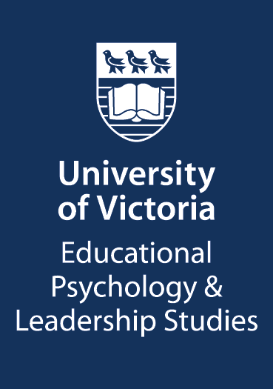 | University of Victoria Posting  CUPE 4163 Specialist Instructional

Position Title:  Teaching Assistant Coordinator | Appointment From: Sept 4, 2024 To: Dec 23, 2024
Department: EPLS | Instructor: Dr. Mariel Miller
Hourly Rate: $ 31.80 | Hours Available:  1 TA Coordinator x 50 hours
Course:  ED-D 101  Learning Strategies for University Success | Course Description:  ED-D 101 is a first year undergraduate course examining learning behaviours and motivations for improving academic success. The course introduces educational psychology theories, principles and research with a focus on self-regulation - the science of strategic, reflective, and adaptive learning. Students are required to master knowledge and apply concepts related to learning, motivation, collaboration, academic performance, and procrastination. Taken as an elective course by students across almost all faculties on campus. Computers are used extensively for applied lab work and assignments.
Required Qualifications and Experience:
Graduate students with previous experience as a sessional instructor or TA for ED-D 101 are invited to apply. Preference will be given to students currently enrolled in an Educational Psychology or Counselling program in the EPLS department.
Job Description/Responsibilities:

The ED-D 101 TA Coordinator will work as part of a dynamic graduate student teaching team to support TAs to coach undergraduate students in a small class setting (20 students). Professional development support and mentorship will be provided as part of the paid hours.

Responsibilities include:

- Providing training, leadership and guidance to a small group (4-7) of ED-D 101 teaching assistants (TAs) to ensure TAs are well supported in coaching their assigned learning communities
- Working with the primary ED-D 101 instructor to update and create TA Support materials including updated lesson plans and activity guides
- Supporting TAs to host office hours and respond to student inquiries
- Coordinating, assisting with, and providing quality assurance for student feedback
- Additional responsibilities include facilitating TA instructional team meetings (online).

Note: We are looking for people who are compassionate and committed to supporting undergraduate students and facilitating the development of supportive relationships with these students.
How To Apply:
Please complete the ED-D 101 Application Form, by July 31, 2024
Shortlisted applicants will have informal interview (via Zoom) in early August
It is anticipated the final employment decision will be made by: August 15, 2024

Appointments will be made in accordance with Article 13.02 (Appointment Procedures) and Appendix A of the CUPE 4163 Collective Agreement. Selection criteria will include: qualifications and ability based on academic merit and related experience, the career and/or pedagogical value that the experience in a particular position will provide the student, the student’s preferences, and other sources of graduate student financial support being received. See Schedule 1 in the Collective Agreement for wages. Application does not ensure employment.

The University of Victoria is an equity employer and encourages applications from
women, persons with disabilities, visible minorities and aboriginal persons.

